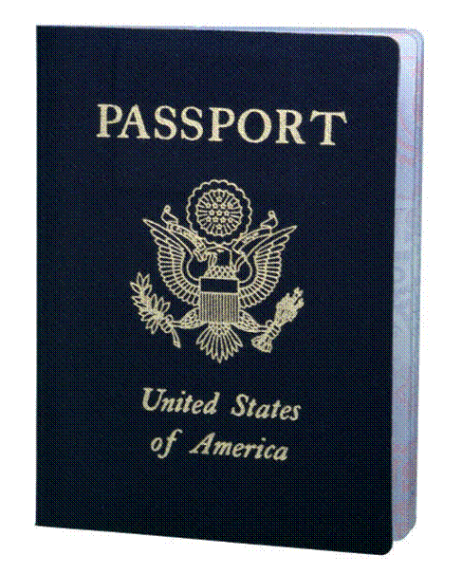
PASSPORT RENEWAL PROCESS
Who’s eligible for renewal? If you do not meet these criteria, you must fill out the DS-11 and make an appointment to have the passport processed at an acceptance agency.
  - Your previous passport was an adult 10 year passport.
  - If you still have possession of your passport and it has not been damaged.
  - Your passport has been issued in the last 15 years.
  - Your previous passport was not limited for any reason.
  - You have the same name or can submit a certified copy of the reason for the name change (marriage certificate, court order, etc.)
  - You can only renew a passport card if you’ve been issued one in the last 15 years.
What you need to do:
  - Fill out and sign form DS 82. Available online at www.travel.state.gov, in our office or most Post Offices. USE BLACK INK ONLY!
  - Get a new passport photo and attach it to the front of the application with 4 staples
  - Attach a check made out to the U.S. Department of State. Put the applicant’s name and birthdate in the memo area of the check. (Staple to the bottom of the front page)
    - $130.00 (per person) for routine processing
    - $190.00 (per person) for expedited processing
    - Passport cards are an additional $30.00 (must have previous card)
  - Open the passport book and staple through the open book to attach it to the back page.
Mail everything to the appropriate location using a method that includes tracking:
For Routine Processing:  (Use Priority Mail) | For Expedited Processing  (Use Priority Express Mail)
National Passport Processing Center  P.O. Box 90155  Philadelphia, PA 19190-0155 | National Passport Processing Center  P.O. Box 90955  Philadelphia, PA 19190-0955

